Workshop Web Server
(TIF330805)

LAPORAN



ACARA 22

ALEXSYS WAHYU SAPUTRA
NIM E41250598

TEKNIK INFORMATIKA KAB. NGANJUK
JURUSAN TEKNOLOGI INFORMASI
POLITEKNIK NEGERI JEMBER
TAHUN 2026

Acara 22

Prosedur Kerja
Dokumentasi Markdown acara 21 dikonversi menjadi OpenAPI 3.0, dengan path yang mengikuti resource pada peta Router (bukan lagi nama berkas .php).

Langkah 1 — Membuat File openapi.yaml
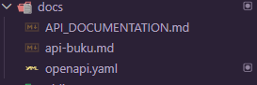

Langkah 2 — Mendefinisikan Path /login
/api/login:
post:
tags: [Autentikasi]
summary: Login dan memperoleh token Bearer
operationId: loginUser
requestBody:
required: true
content:
application/json:
schema:
$ref: '#/components/schemas/LoginRequest'
example:
username: admin
password: rahasia123
responses:
'200':
description: Login berhasil
content:
application/json:
schema:
$ref: '#/components/schemas/LoginResponse'
'400':
description: JSON tidak valid atau body bukan object JSON
content:
application/json:
schema:
$ref: '#/components/schemas/ApiResponse'
'401':
description: Username atau password salah
content:
application/json:
schema:
$ref: '#/components/schemas/ApiResponse'
'415':
description: Content-Type bukan application/json
content:
application/json:
schema:
$ref: '#/components/schemas/ApiResponse'
'422':
description: Username atau password kosong
content:
application/json:

Langkah 3 — Mendefinisikan Path /mahasiswa
/api/mahasiswa:
get:
tags: [Mahasiswa]
summary: Mengambil seluruh data mahasiswa
operationId: listMahasiswa
responses:
'200':
description: Data mahasiswa berhasil diambil
content:
application/json:
schema:
$ref: '#/components/schemas/MahasiswaListResponse'
'500':
$ref: '#/components/responses/ServerError'
post:
tags: [Mahasiswa]
summary: Menambahkan data mahasiswa
operationId: createMahasiswa
security:
- bearerAuth: []
requestBody:
required: true
content:
application/json:
schema:
$ref: '#/components/schemas/MahasiswaRequest'
example:
nim: '241250599'
nama: Dewi Lestari
email: dewi@example.com
prodi_id: 2
angkatan: 2024
responses:
'201':
description: Data mahasiswa berhasil ditambahkan
content:
application/json:
schema:
$ref: '#/components/schemas/MahasiswaResponse'
'400':
$ref: '#/components/responses/BadRequest'
'401':
$ref: '#/components/responses/Unauthorized'
'409':
description: NIM sudah terdaftar
content:
application/json:
schema:
$ref: '#/components/schemas/MahasiswaResponse'
'415':
description: Content-Type bukan application/json
content:
application/json:
schema:
$ref: '#/components/schemas/MahasiswaResponse'
'422':
description: Format NIM tidak valid atau data program studi belum tersedia
content:
application/json:
schema:
$ref: '#/components/schemas/MahasiswaResponse'
Langkah 4 — Memvisualisasikan Dokumentasi
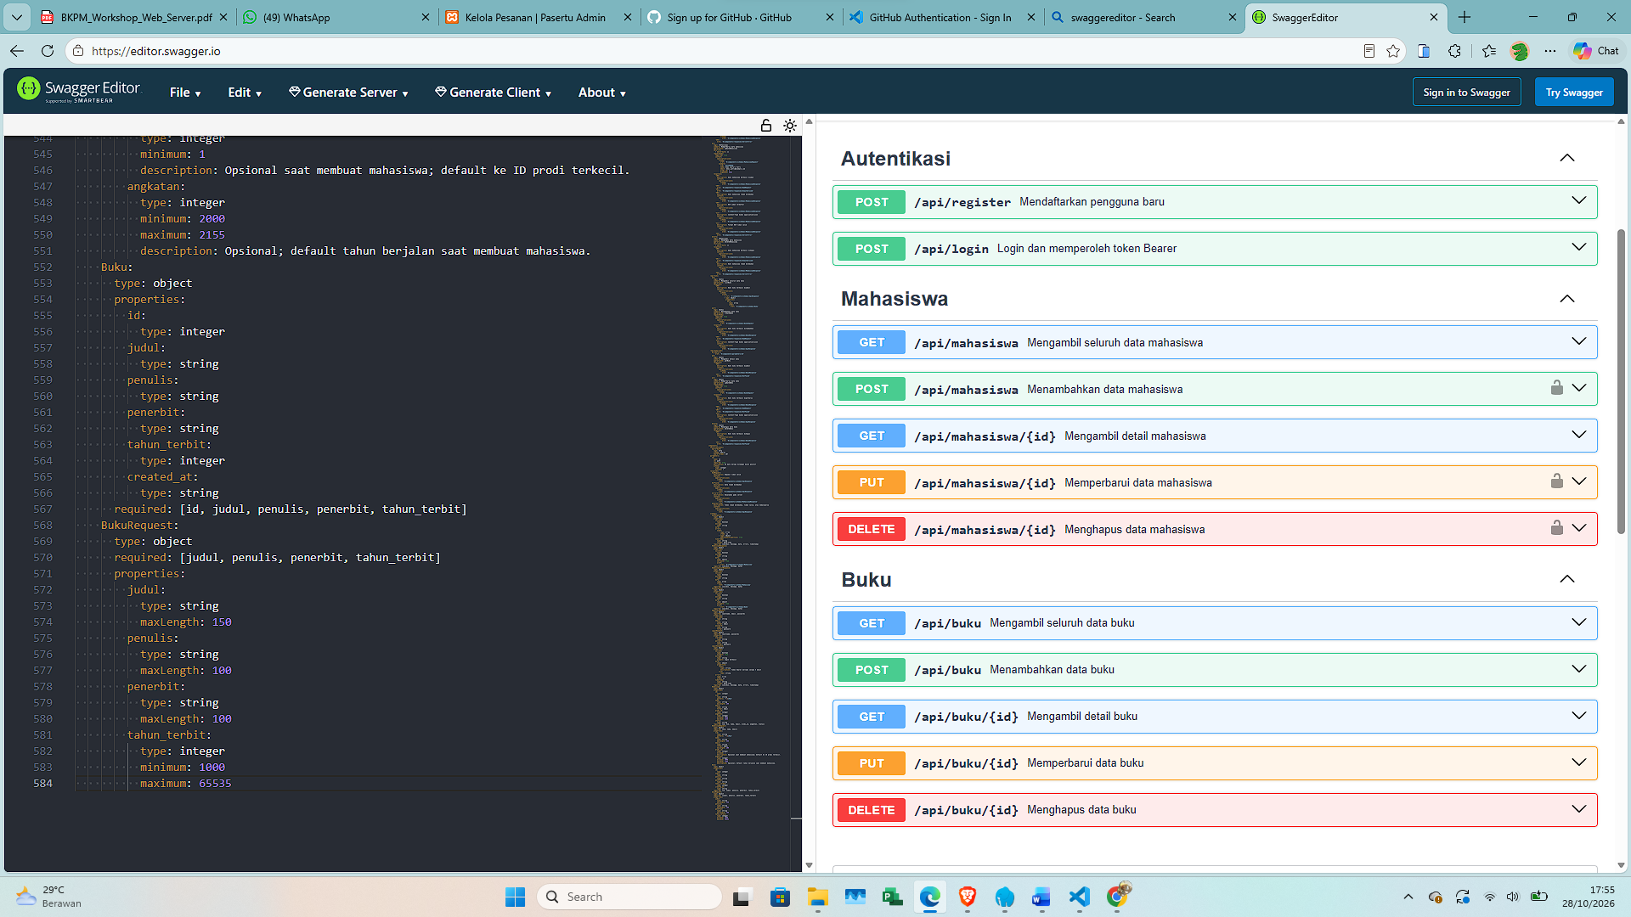

Tugas Praktik Mandiri
- Lengkapi seluruh path pada openapi.yaml (PUT dan DELETE /mahasiswa, serta /register) mengikuti pola yang sama.
- Register
/api/register:
post:
tags: [Autentikasi]
summary: Mendaftarkan pengguna baru
operationId: registerUser
requestBody:
required: true
content:
application/json:
schema:
$ref: '#/components/schemas/RegisterRequest'
example:
username: admin
email: admin@example.com
password: rahasia123
responses:
'201':
description: Registrasi berhasil
content:
application/json:
schema:
$ref: '#/components/schemas/ApiResponse'
'409':
description: Username atau email sudah terdaftar
content:
application/json:
schema:
$ref: '#/components/schemas/ApiResponse'
'422':
description: Field wajib kosong atau format email tidak valid
content:
application/json:
schema:
$ref: '#/components/schemas/ApiResponse'
'400':
description: Registrasi gagal karena kesalahan penyimpanan
content:
- Mahasiswa
put:
tags: [Mahasiswa]
summary: Memperbarui data mahasiswa
operationId: updateMahasiswa
security:
- bearerAuth: []
requestBody:
required: true
content:
application/json:
schema:
$ref: '#/components/schemas/MahasiswaRequest'
example:
nim: '241250599'
nama: Dewi Lestari Putri
email: dewi.putri@example.com
prodi_id: 2
angkatan: 2024
responses:
'200':
description: Data mahasiswa berhasil diubah
content:
application/json:
schema:
$ref: '#/components/schemas/MahasiswaResponse'
'400':
$ref: '#/components/responses/BadRequest'
'401':
$ref: '#/components/responses/Unauthorized'
'404':
description: Data mahasiswa tidak ditemukan
content:
application/json:
schema:
$ref: '#/components/schemas/MahasiswaResponse'
'409':
description: NIM sudah terdaftar
content:
application/json:
schema:
$ref: '#/components/schemas/MahasiswaResponse'
'415':
description: Content-Type bukan application/json
content:
application/json:
schema:
$ref: '#/components/schemas/MahasiswaResponse'
'422':
description: Format NIM tidak valid
content:
application/json:
schema:

- Tambahkan komponen securitySchemes bertipe http/bearer pada bagian components.
components:
securitySchemes:
bearerAuth:
type: http
scheme: bearer
bearerFormat: JWT

